Using Qt to build a WINCC OA EWO

Table of contents

1 NFormation 1
2 Create a visual studio project 2
2.1 Introduction 2
2.2 Create project 2
2.3 Add source files 4
3 QT makefile 6
3.1 Introduction 6
3.2 Create .PRO 6
3.3 Create the makefiles 8
3.4 Changes to the makefile 9
4 Building from visual studio 11
4.1 Introduction 11
4.2 Visual Studio and the windows environment 11
4.3 The API_ROOT 12
4.4 Building the target 13
4.5 Cleaning the target 14
4.6 Rebuilding the target 14
5 testing the ewo 15
5.1 Introduction 15
5.2 Adding it to a project 15
5.3 Add the ewo to a panel 16
5.4 Turn on the light 19
6 Debugging the ewo 21
6.1 Introduction 21
6.2 Settings for debugging 22
6.3 Breakpoints 22
7 APPENDIX 24
7.1 Source for Flashlight.cxx 24
7.2 Source for Flashlight.hxx 28
7.3 Batch files 29
7.4 Makefile 30

INFormation
This document show how Qt can be used to implement a WinCC OA widget. A widget is very much like an ActiveX. The benefit of building a Qt widget is:

- A widget integrates best into WinCC OA
- A widget requires no registration
( an ActiveX needs to be registered on every client computer )
- A widget can be transparent
- A widget uses the beautiful and rich Qt libraries

This document will use the various open source Qt tools, and the Visual Studio 2008 Express Edition to build the EWO.

You could of course decide to use the (open source ) Qt Creator. However, I wanted to use Visual Studio. Also, I had some difficulties when debugging my ewo in Creator and decided to switch to Visual Studio.

“Share the fun”

Frenk Mulder
September 2011

Create a visual studio project

Introduction
This chapter will first create a Visual Studio project. We then change the appropriate settings so that we can then compile and link against the Qt libraries.

We will implement a ‘flashlight’ widget. That is : a beam of light that moves over the PVSS panel when you move the mouse.

Create project
Start Visual Studio and create a new project:

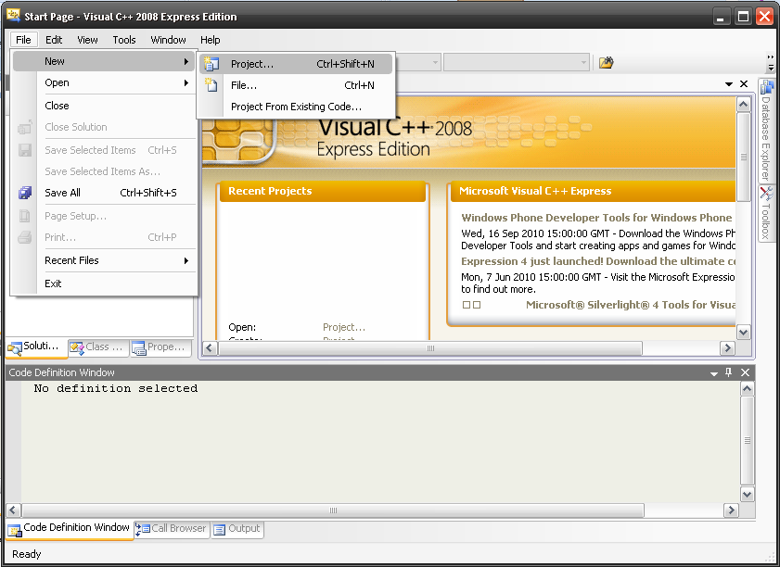
Figure 1 Create new Visual Studio project

Create a ‘makefile’ project:

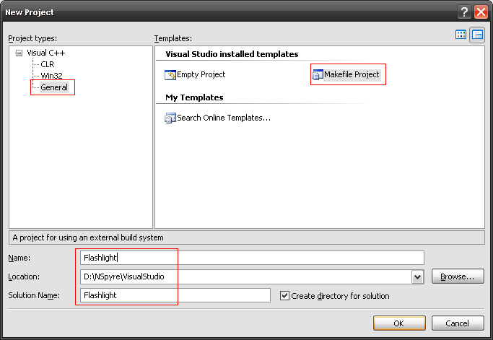
Figure 2 Project type 'makefile'

A page will show where you need to type the various build settings. Note that we don’t care about the debug settings. Type whatever you want. The thing we really want is the makefile for release mode.

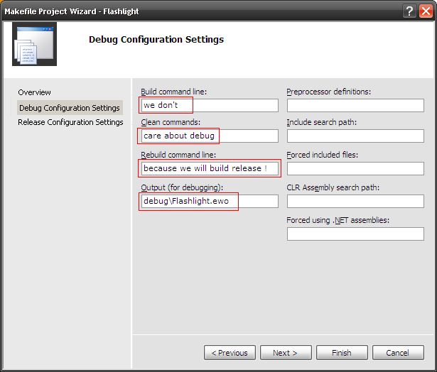
Figure 3 Settings for debug build

The next page will show the build settings for release mode.

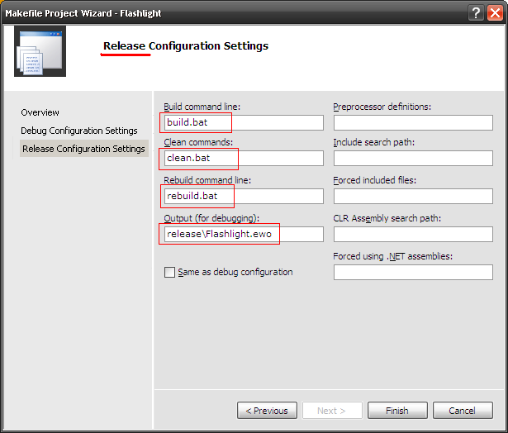
Figure 4 Settings for release build

Note that we’ve just defined some batch files that we will call when building our ewo. We will fill in the batch files later on

Add source files
We’ll add some sample source files ( you’ll find the source in the appendix ). These files will implement the full source code for the widget.

Copy the source code found in the Appendix and copy them into the files Flashlight.cxx and Flashlight.hxx !

Choose ‘Add – Existing item’ to add the two source files ( shown in the appendix )

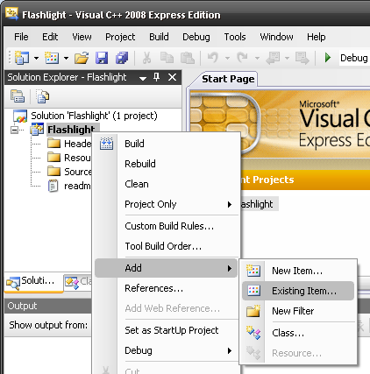
Figure 5 Add source files to project

Then add the files Flashlight.cxx and Flashlight.hxx:

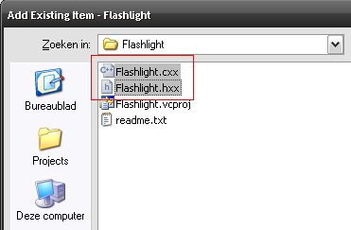
Figure 6 Add files flashlight.*

QT makefile

Introduction
Qt uses a command line tool called QMake to :

- Create a project file ( extension *.pro )
- Create the makefiles ( from the .pro file )

This chapter will use the QMake tool to eventually create the makefiles for debug and release mode.

Debug or release
The QMake tool will produce a makefile for release and for debug mode. The difference between debug and release being:

- The debug version links other libraries that have more checks
- The compiler will include information needed when debugging
- The linker will create the *.PDB file ( program database )

Linking against the debug versions of the Qt libraries has a major disadvantage. It could be that your development works well in the debugger but crashes when you build the release version.

This is why all WinCC OA modules are compiled as follows:

- Build release version
- Add option ‘-Zi’ to the compiler so that debugging information is added to the compiled object files
- Add option ‘/DEBUG’ to the linker so that the *.PDB file is being generated

Create .PRO
Create the *.pro file by calling:

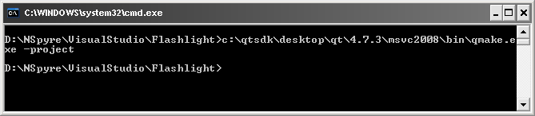

Note:
The Qt installation comes with various QMake versions. Make sure to choose the version that matches this compiler

The file that has been created looks like:

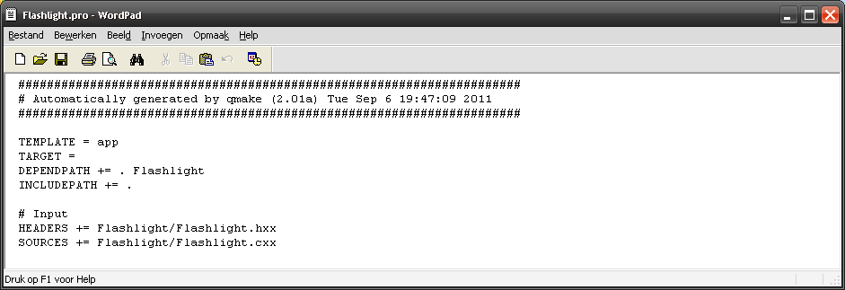
Figure 7 Flashlight.pro generated by qmake

We are going to manually make some changes to the file ( Look at the sample file in folder ‘C:\Siemens\Automation\WinCC_OA\3.10\api\TemplateEWO’ ). This will tell the compiler to link against the ewo library ( ewo.lib ) and where to find the header files ( *.hxx ).

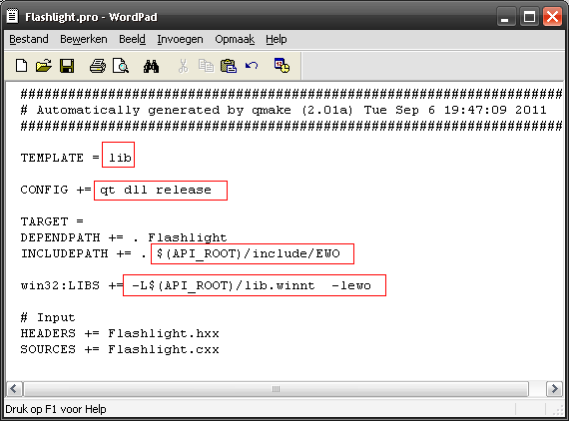
Figure 8 Flashlight.pro modified for WinCC OA widget

Create the makefiles
The QMake tool is also used to create the makefiles after reading the .pro file. This is done by calling the following command:

c:\qtsdk\desktop\qt\4.7.3\msvc2008\bin\qmake.exe

This will create the following two makefiles:

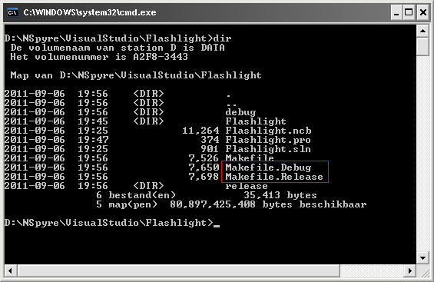
Figure 9 Makefiles created by qmake

Changes to the makefile
All PVSS managers are normally compiled in release mode ( see paragraph 3.1.1 ). This means that we will only need to modify the file called makefile.release :

- Add compiler option ‘-Zi’
- Add linker option’/DEBUG’
- Change the target so that the EWO is linked into the proper folder

The following figure shows changes for compiler, linker options and target file so that the EWO is built directly in our WinCC OA test project.

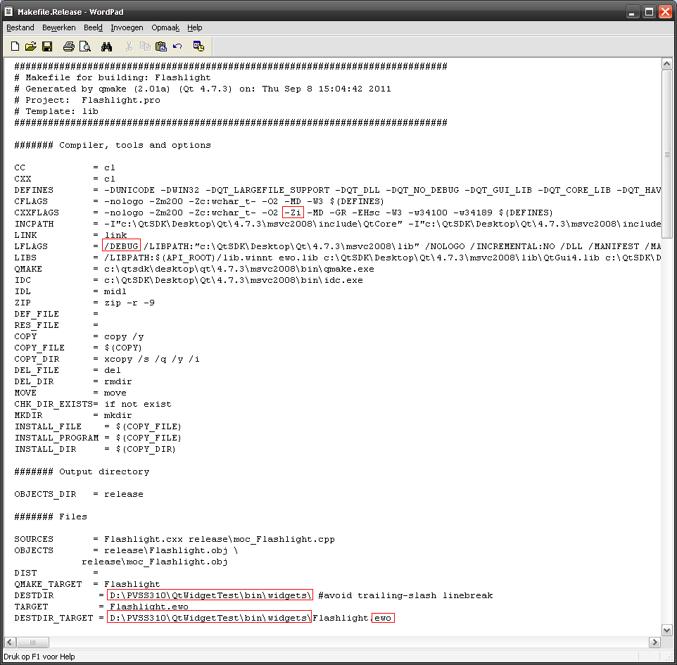
Figure 10 Changes to makefile.release

Building from visual studio

Introduction
The previous chapter showed how the makefile ( ‘makefile.release’ ) was generated by the QMake tool. We’ve also defined the names of the batch files that can be used to build, clean or rebuild the ewo.

This chapter will describe the steps to actually build the ewo. This means that we need to define the batch files that Visual studio will call.

Visual Studio and the windows environment
The batch files will eventually call external programs like cl.exe ( compiler ) and link.exe ( linker ). However, it could very well be that these programs can not be found because your PATH variable is not setup right or other environment variables are incorrect.

This can be tested by typing ‘cl’ in a dos prompt.

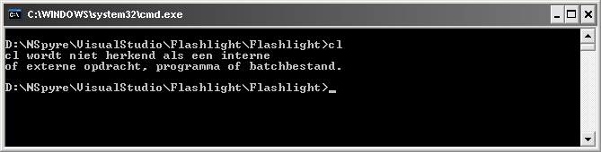

The easiest way to solve this is :

- Start the Visual studio 2008 command prompt.
( This command prompt will have the right PATH en environment variables )
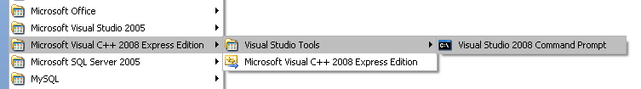
- ( stay in the command prompt !! ) Navigate to the folder where your ewo project is.
Note: that the Microsoft compiler is actually found when you now type cl !
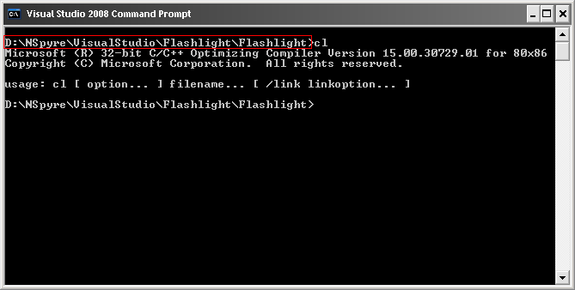
- Type the name of the file with extension ‘vapor’ and press <enter>. This should now start your Visual studio environment.
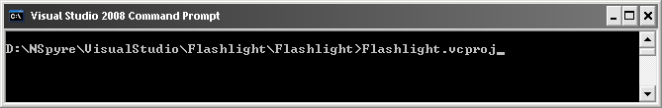

The API_ROOT
All WinCC OA modules ( drivers, managers, ewo’s ) require an environment variable API_ROOT that refers to the \api folder in the product installation folder.

There are several options to set this environment variable:

- You can permanently set this environment variable for your computer
- You can manually set it, every time when you start Visual Studio
- ….. you can add it to the batch file used to build the software

This chapter will use the third option. The API_ROOT environment variable is set from each of the batch files.

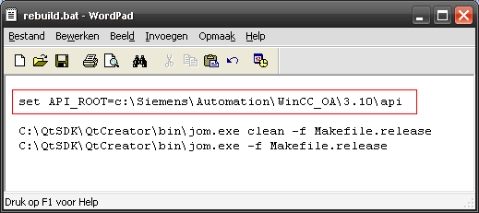
Figure 11 Batchfile rebuild.bat

Building the target
The previous paragraphs ( see Figure 4 Settings for release build ) showed how a batch file ‘build.bat’ will be called from Visual Studio to build our target.

The batch file build.bat looks as follows:

set API_ROOT=c:\Siemens\Automation\WinCC_OA\3.10\api
C:\QtSDK\QtCreator\bin\jom.exe -f Makefile.release

To build the EWO:

- Make sure your Visual studio is configured to build release ( and not debug )
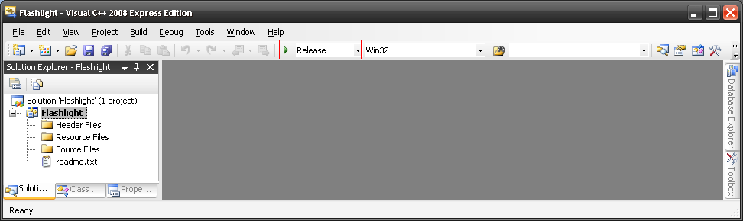
- Choose menu item ‘Build – Solution’

Cleaning the target
The batchfile ‘clean.bat’ is more-or-less the same.

set API_ROOT=c:\Siemens\Automation\WinCC_OA\3.10\api
C:\QtSDK\QtCreator\bin\jom.exe clean -f Makefile.release

Rebuilding the target
The batchfile ‘rebuild.bat’ is a combination of the previous 2 batch files:

set API_ROOT=c:\Siemens\Automation\WinCC_OA\3.10\api
C:\QtSDK\QtCreator\bin\jom.exe clean -f Makefile.release
C:\QtSDK\QtCreator\bin\jom.exe -f Makefile.release

testing the ewo

Introduction
This chapter will show how the EWO can be added to a WinCC OA project and how it can added to a WinCC OA panel. It will also show how the proper method can be called to turn on the flashlight.

Adding it to a project
The ewo can be placed in three possible locations:

- You could add the eow to the \bin\widtgets folder of the folder where WinCC OA was installed.
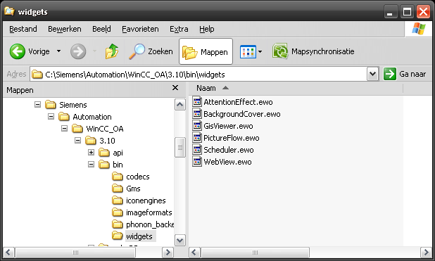
- You could make a sub-project and add the ewo there
- You could add the ewo to the folder \bin\widgets of your project.

This document takes the third approach. Note that we’ve changed the target in the file makefile.release so that it directly links into a WinCC OA test project:

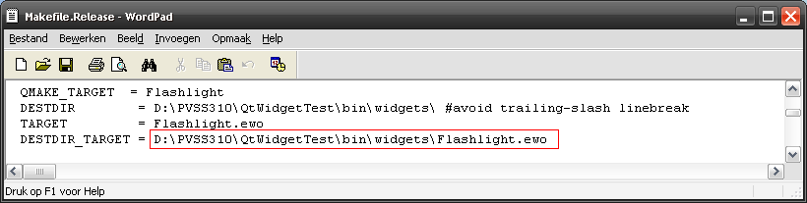

Add the ewo to a panel
An ewo can be added to a panel by clicking the button with tooltip EWO ( External Widget Object ).

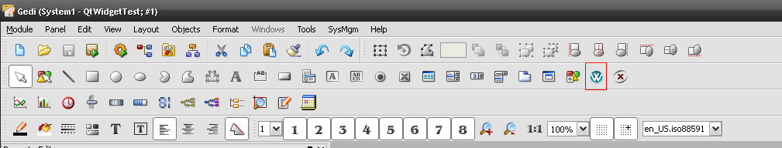

To add the ewo to a test panel:
- Create a new panel
- Put some random shapes in the panel. ( this will help us when demonstrating the ewo later on )
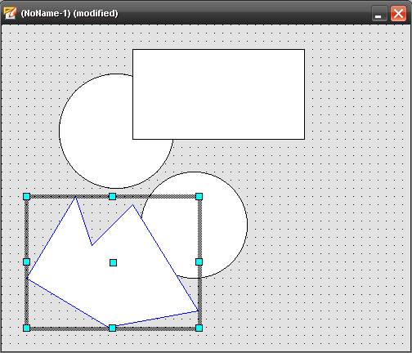
- Click the button ‘EWO’
- A file selector will appear. Choose the file flashlight.ewo that we’ve compiled and linked earlier
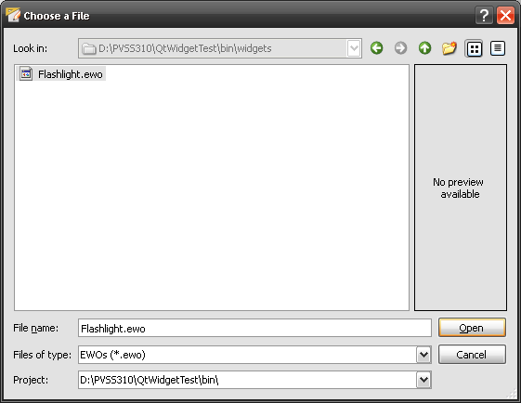
- Now drag an area to position the ewo. Note that the EWO will now cover the shapes you’ve put in earlier.
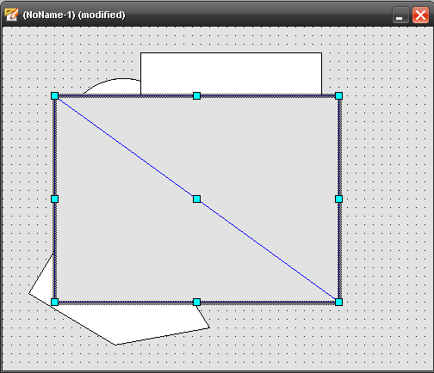
- The ewo will appear with a default grey color. This means that it will cover the previous shapes. We can now change the background color of the ewo to a transparent color.
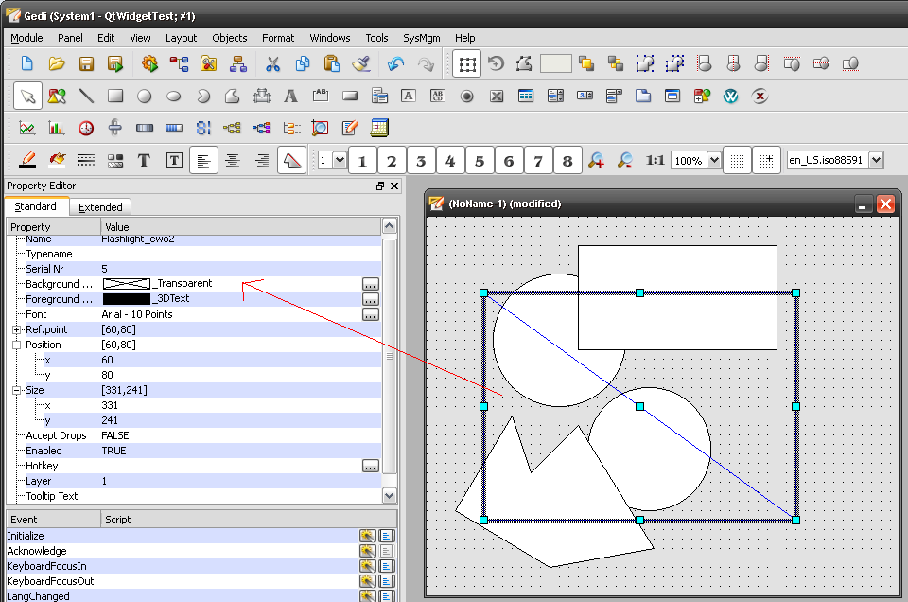

Turn on the light
The EWO has methods to active the beam of light. This is done by calling the method ‘flashLightOn()’.

- Add a button to the panel and make it call the method ‘flashLightOn()’ of the EWO
( make sure to use the proper name of the ewo object or type <ctrl>-O to find it )
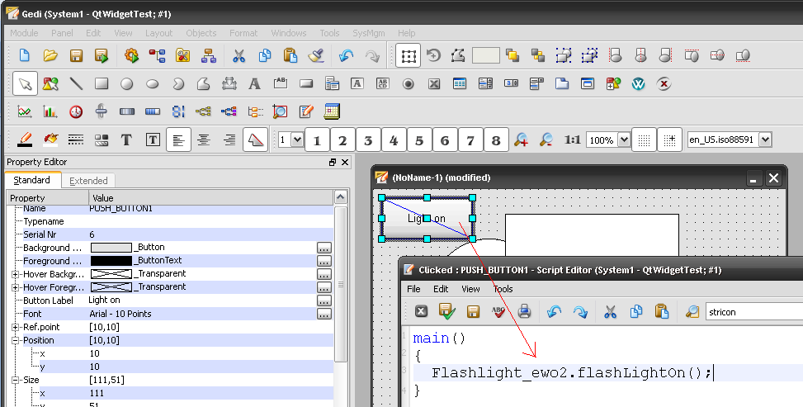
- Save and run the panel
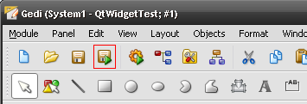
- Click the button to turn on the flashlight !
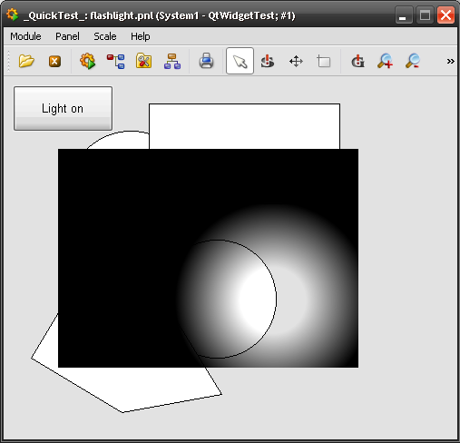
- Use the mouse wheel to make the beam of light bigger or smaller
- Click the mouse anywhere in the ewo to turn of the flashlight

Debugging the ewo

Introduction
The settings in the previous chapters would build a release version of the ewo. However, the modified makefile would add debug info to the compiled program ( ‘-zi’ ) and produce the PDB file ( /DEBUG ).

Also note that we have changed the target so that the ewo is already in the right location, ready to be debugged with Visual Studio.

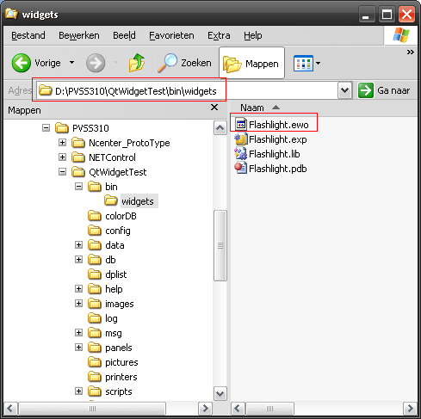

Settings for debugging
Choose the menu item Project – Properties and set the following properties:

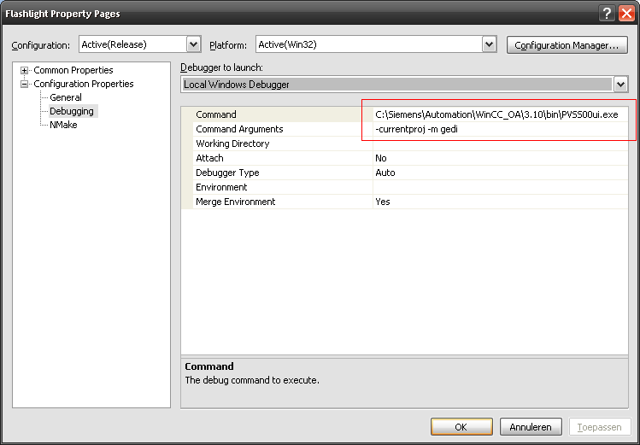

The command arguments for the PVSS00UI are identical to the settings you’d define in the WinCC OA Console. The only difference is the additional option ‘-currentproj’ which tells your PVSS00UI user interface what project to connect to.

Breakpoints
You can now set breakpoints in your code and start the debugger via key <F5>

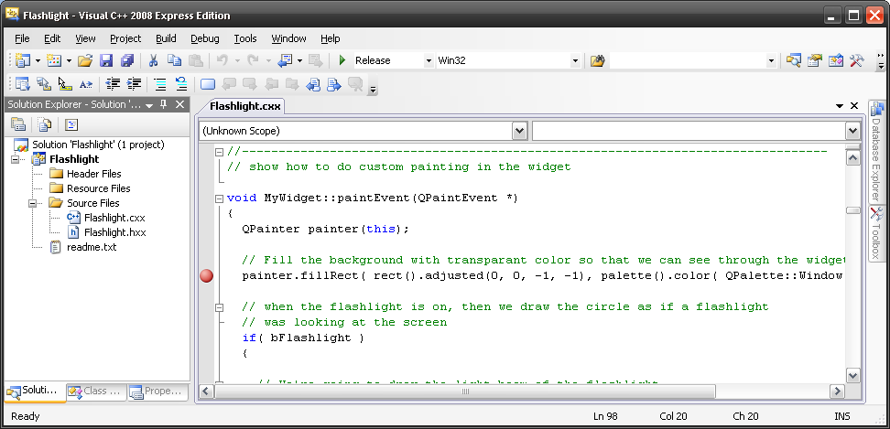
The debugger will probably complain that the program PVSS00Ui doesn’t contain any debug information. Just ignore this message and continue.

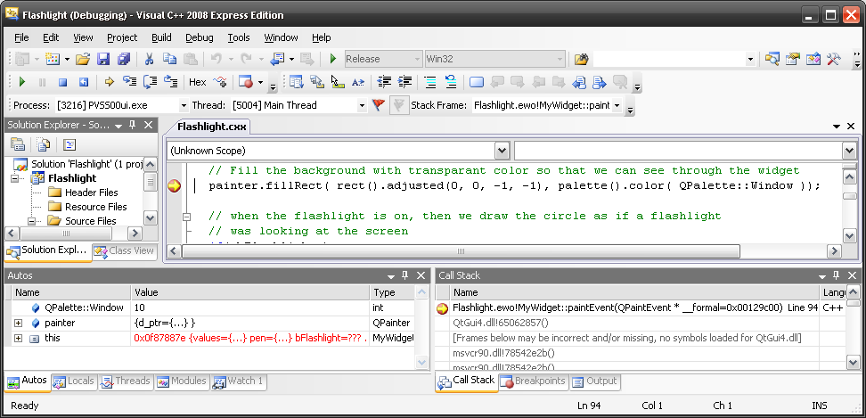

APPENDIX

Source for Flashlight.cxx
// ************************************
// Name : Flashlight
// ************************************
// Description:
// This ( pretty useless ) EWO will demonstrate
// the various techniques that you'll need when
// building an EWO for WinCC OA
//
// The code will demonstrate:
// - The general framework
// - How to make an EWO transparent
// - Adding methods that you can call from PVSS ( Look for 'FlashLightOn' )
// - Firing events to PVSS ( Look for 'BeamRadiusChanged' )
// - Reacting on events
// - Mouse move events ( see MyWidget::mouseMoveEvent() )
// - Mouse button press ( see MyWidget::mousePressEvent() )
// - Mouse wheel events ( see MyWidget::wheelEvent() )
// - Setting and getting properties ( look for the property 'beamRadius' )
// - How to pass complex PVSS data types to the EWO
//
// *************************************

#include <Flashlight.hxx>

#include <QPushButton>
#include <QLayout>
#include <QDateTime>
#include <QPolygon>
#include <QPainter>
#include <QMap>
#include <QMouseEvent>

//--------------------------------------------------------------------------------

EWO_PLUGIN( Flashlight )

//--------------------------------------------------------------------------------
// Here comes the implementation of the widget itself.
// The widget itself is a normal Qt widget and does not need to know
// anything about PVSS or the EWO interface
//--------------------------------------------------------------------------------

MyWidget::MyWidget(QWidget *parent)
: QWidget(parent)
{

// This widget will display a flashlight beam.
// We turn the beam of by default.

// Flashlight is of by default
bFlashlight = false;

iBeamRadius = 300;
}

//--------------------------------------------------------------------------------

void MyWidget::intf_setFlashLightOn()
{
// We want our widget to receive mouse evenets
// ( even when the mouse button is not pressed )
setMouseTracking( true );

bFlashlight = true;
update();
}

//--------------------------------------------------------------------------------

void MyWidget::intf_setFlashLightOff()
{
// We no longer need mouse move events
setMouseTracking( false );

bFlashlight = false;
update();
}

//--------------------------------------------------------------------------------
// show how to do custom painting in the widget

void MyWidget::paintEvent(QPaintEvent *)
{
QPainter painter(this);

// Fill the background with transparant color so that we can see through the widget
painter.fillRect( rect().adjusted(0, 0, -1, -1), palette().color( QPalette::Window ));

// when the flashlight is on, then we draw the circle as if a flashlight
// was looking at the screen
if( bFlashlight )
{

// We're going to draw the light beam of the flashlight
// The center of the beam is at the mouse position
// The beam has a width that can be modified by
// using the mouse wheel
QRadialGradient flashLight(
pointMouse.x(), // We're gone draw the beam at the cursor
pointMouse.y(), // position. Beam will follow the mouse
iBeamRadius ); // The radius can be chanegd with the wheel
flashLight.setColorAt(0, QColor( 20, 20, 20, 0) );
flashLight.setColorAt(0.2, QColor( 20, 20, 20, 0) );
flashLight.setColorAt(0.6, QColor( 0, 0, 0 ) ) ;

// We're gong create a brush based on our gradient
QBrush FlashBrush( flashLight );
painter.setBrush( FlashBrush );

// We now just fill the entire area.
// The radial gradient will create the beam effect
painter.drawRect( 0, 0, width(), height() );
}

}

//--------------------------------------------------------------------------------

void MyWidget::mouseMoveEvent(QMouseEvent *event )
{
// All we do here is record the position of the mouse.
// We'll need this position to set the center of our beam
pointMouse = event->pos();

// When our beam is on, then we need to redraw
// the beam at the new position
if( bFlashlight )
update();
}

//--------------------------------------------------------------------------------

// ********************************
// Name : mousePressEvent
// ********************************
// Description:
// Is called when they press one of the mouse buttons.
// We will look at the left mouse button.
// When they click the left mouse button,
// then we turn of the light
//
// ********************************

void MyWidget::mousePressEvent(QMouseEvent *event )
{

// The left mouse button can be used to select an area
if ( (event->type() == QEvent::MouseButtonPress) && (event->button() == Qt::LeftButton) )
{
intf_setFlashLightOff();
}
}

void MyWidget::wheelEvent(QWheelEvent *event)
{
iBeamRadius += event->delta();

// When our beam is on, then we need to redraw
// the beam with the new radius
if( bFlashlight )
{
update();

emit signalBeamRadiusChanged( iBeamRadius );
}
}

//--------------------------------------------------------------------------------
// Here comes the implementation of the EWO interface class
// The EWO interface class is just a wrapper around a normal Qt widget
// and it gives PVSS a standard interface to communicate with it.
// In our example we use our own "MyWidget"
//--------------------------------------------------------------------------------

Flashlight::Flashlight(QWidget *parent)
: BaseExternWidget(parent)
{
// the widget will be deleted by the QWidget parent
// Don't do it in destructor
baseWidget = new MyWidget(parent);

// TODO here come your app specific things
// we connect the signals from our widget to our interface slots
// so we can forward them to PVSS
connect(baseWidget, SIGNAL(signalBeamRadiusChanged(int)), this, SLOT(signalBeamRadiusChanged(int)));

}

//--------------------------------------------------------------------------------

QWidget *Flashlight::widget() const
{
return baseWidget;
}

//--------------------------------------------------------------------------------

QStringList Flashlight::signalList() const
{
QStringList list;

// TODO for every signal you can emit, add one entry with the correct signature
// See BaseExternWidget.hxx
list.append("BeamRadiusChanged(int iRadius)");

return list;
}

//--------------------------------------------------------------------------------

QStringList Flashlight::methodList() const
{
QStringList list;

// Add the methods of this EWO
list.append("void flashLightOn()");
list.append("void flashLightOn()");

return list;
}

//--------------------------------------------------------------------------------
// this method is optional, but as the PVSS user will pass a string
// from the PVSS color-database as a string, we must tell PVSS that we want to
// have a QColor object and not a QString here.
// Doing so allows to pass any static PVSS color either by name or whatever
// syntax PVSS provides from a CTRL script and the string from the script
// will be converted into a correct QColor.
// The same needs to be done with other datatypes where Qt uses special classes
// but the PVSS CTRL scripting language represents these differently, e.g.
// a QColor as a string, a QBrush as a string, a QPoint as a dyn_int, ...

bool Flashlight::methodInterface(const QString &name, QVariant::Type &retVal,
QList<QVariant::Type> &args) const
{

// Tell PVSS what kind of parameters we expect in our methods
if( name == "flashLightOn")
{
return true;
}

if( name == "flashLightOn")
{
return true;
}

// Method not supported
return false;

}

//--------------------------------------------------------------------------------

QVariant Flashlight::invokeMethod(const QString &name, QList<QVariant> &values, QString &error)
{
// TODO check for the method to invoke
// all methods here are only examples and usually
// not useful as they are

// call the proper methods of our widget
if( name == "flashLightOn")
{
if ( !hasNumArgs(name, values, 0, error) ) return QVariant();
baseWidget->intf_setFlashLightOn();
}

if( name == "flashLightOff")
{
if ( !hasNumArgs(name, values, 0, error) ) return QVariant();
baseWidget->intf_setFlashLightOff();
}

return QVariant();

}

//--------------------------------------------------------------------------------

void Flashlight::signalBeamRadiusChanged( int newRadius )
{
QList<QVariant> values;
values.append(newRadius);

emit signal("BeamRadiusChanged", values);
}

Source for Flashlight.hxx
#ifndef _Flashlight_H_
#define _Flashlight_H_

#include <BaseExternWidget.hxx>
#include <QPen>
#include <QBrush>

//--------------------------------------------------------------------------------
// this is the real widget (an ordinary Qt widget), which can also use Q_PROPERTY

class MyWidget : public QWidget
{
Q_OBJECT

// We'll add a property that is visibile in the list of properties
// in the WinCC OA Graphical Eitor ( GEDI )
// ( Note : the option 'DESIGNABLE true' is needed so that you'll be able to modify the property.
// when you use false, then you can only set property via scripting )
Q_PROPERTY( int beamRadius READ getBeamRadius WRITE setBeamRadius DESIGNABLE true )

public:
MyWidget(QWidget *parent);

// Make the functions to 'Get' and 'Set' the beam radius
int getBeamRadius() { return iBeamRadius; };
void setBeamRadius(int i ) { iBeamRadius = i; };

// These are the methods that we call from the outside world
// ( We have given them a prefix 'intf_' so that it is clear
// that they are the interface functions )
void intf_setFlashLightOn();
void intf_setFlashLightOff();

// We override some virtual functions
void mouseMoveEvent(QMouseEvent *event );
void mousePressEvent(QMouseEvent *event );
void wheelEvent(QWheelEvent *event);

signals:
// TODO example of a 2 signals this widget emits
void signalBeamRadiusChanged( int );

protected:
virtual void paintEvent(QPaintEvent *event);

private:
// TODO example of a string list property
QStringList values;
QPen pen;

bool bFlashlight;
QPoint pointMouse;
int iBeamRadius;
};

//--------------------------------------------------------------------------------
// this is the EWO interface class

class EWO_EXPORT Flashlight : public BaseExternWidget
{
Q_OBJECT

public:
Flashlight(QWidget *parent);

virtual QWidget *widget() const;

virtual QStringList signalList() const;

virtual bool methodInterface(const QString &name, QVariant::Type &retVal,
QList<QVariant::Type> &args) const;

virtual QStringList methodList() const;

public slots:
virtual QVariant invokeMethod(const QString &name, QList<QVariant> &values, QString &error);

private slots:
// TODO the slots you need to redirect to the generic "signal" signal
void signalBeamRadiusChanged( int );

private:
MyWidget *baseWidget;
};

#endif

Batch files
This paragraph will describe the various batch files that we’ve used when building the ewo.

Source for make_pro.bat
The following batch file will create the file with extension *.pro

c:\qtsdk\desktop\qt\4.7.3\msvc2008\bin\qmake.exe –project

source for make_makefiles.bat
The batch file make_makefiles.bat will start qmake and instruct it to generate makefile.debug and makefile.release

c:\qtsdk\desktop\qt\4.7.3\msvc2008\bin\qmake.exe

Source for build.bat
Build.bat will call jom.exe to build the ewo

set API_ROOT=c:\Siemens\Automation\WinCC_OA\3.10\api
C:\QtSDK\QtCreator\bin\jom.exe -f Makefile.release

Source for rebuild.bat
Clean.bat will first ‘clean the project and will then call jom to rebuild the entire ewo

set API_ROOT=c:\Siemens\Automation\WinCC_OA\3.10\api
C:\QtSDK\QtCreator\bin\jom.exe clean -f Makefile.release
C:\QtSDK\QtCreator\bin\jom.exe -f Makefile.release

Source for clean.bat
The batch file clean.bat will delete all the compiled files so that a clean build can be done.

set API_ROOT=c:\Siemens\Automation\WinCC_OA\3.10\api
C:\QtSDK\QtCreator\bin\jom.exe clean -f Makefile.release

Makefile

source for makefile.release
The file makefile.release was generated by qmake:

#############################################################################
# Makefile for building: Flashlight
# Generated by qmake (2.01a) (Qt 4.7.3) on: Thu Sep 8 15:04:42 2011
# Project: Flashlight.pro
# Template: lib
#############################################################################
####### Compiler, tools and options
CC = cl
CXX = cl
DEFINES = -DUNICODE -DWIN32 -DQT_LARGEFILE_SUPPORT -DQT_DLL -
DQT_NO_DEBUG -DQT_GUI_LIB -DQT_CORE_LIB -DQT_HAVE_MMX -DQT_HAVE_3DNOW -DQT_HAVE_SSE -DQT_HAVE_MMXEXT -DQT_HAVE_SSE2 -DQT_THREAD_SUPPORT
CFLAGS = -nologo -Zm200 -Zc:wchar_t- -O2 -MD -W3 $(DEFINES)
CXXFLAGS = -nologo -Zm200 -Zc:wchar_t- -O2 -Zi -MD -GR -EHsc -W3 -w34100 -w34189 $(DEFINES)
INCPATH = -I"c:\QtSDK\Desktop\Qt\4.7.3\msvc2008\include\QtCore" -I"c:\QtSDK\Desktop\Qt\4.7.3\msvc2008\include\QtGui" -I"c:\QtSDK\Desktop\Qt\4.7.3\msvc2008\include" -I"." -I"$(API_ROOT)\include\EWO" -I"c:\QtSDK\Desktop\Qt\4.7.3\msvc2008\include\ActiveQt" -I"release" -I"c:\QtSDK\Desktop\Qt\4.7.3\msvc2008\mkspecs\default"
LINK = link
LFLAGS = /DEBUG /LIBPATH:"c:\QtSDK\Desktop\Qt\4.7.3\msvc2008\lib" /NOLOGO /INCREMENTAL:NO /DLL /MANIFEST
/MANIFESTFILE:"release\Flashlight.intermediate.manifest"
LIBS = /LIBPATH:$(API_ROOT)/lib.winnt ewo.lib
c:\QtSDK\Desktop\Qt\4.7.3\msvc2008\lib\QtGui4.lib c:\QtSDK\Desktop\Qt\4.7.3\msvc2008\lib\QtCore4.lib
QMAKE = c:\qtsdk\desktop\qt\4.7.3\msvc2008\bin\qmake.exe
IDC = c:\QtSDK\Desktop\Qt\4.7.3\msvc2008\bin\idc.exe
IDL = midl
ZIP = zip -r -9
DEF_FILE =
RES_FILE =
COPY = copy /y
COPY_FILE = $(COPY)
COPY_DIR = xcopy /s /q /y /i
DEL_FILE = del
DEL_DIR = rmdir
MOVE = move
CHK_DIR_EXISTS= if not exist
MKDIR = mkdir
INSTALL_FILE = $(COPY_FILE)
INSTALL_PROGRAM = $(COPY_FILE)
INSTALL_DIR = $(COPY_DIR)
####### Output directory
OBJECTS_DIR = release
####### Files
SOURCES = Flashlight.cxx release\moc_Flashlight.cpp
OBJECTS = release\Flashlight.obj \
release\moc_Flashlight.obj
DIST =
QMAKE_TARGET = Flashlight
DESTDIR = D:\PVSS310\QtWidgetTest\bin\widgets\ #avoid trailing-slash linebreak
TARGET = Flashlight.ewo
DESTDIR_TARGET = D:\PVSS310\QtWidgetTest\bin\widgets\Flashlight.ewo
####### Implicit rules
.SUFFIXES: .c .cpp .cc .cxx
{release}.cpp{release\}.obj::
$(CXX) -c $(CXXFLAGS) $(INCPATH) -Forelease\ @<<
$<
<<
{release}.cc{release\}.obj::
$(CXX) -c $(CXXFLAGS) $(INCPATH) -Forelease\ @<<
$<
<<
{release}.cxx{release\}.obj::
$(CXX) -c $(CXXFLAGS) $(INCPATH) -Forelease\ @<<
$<
<<
{release}.c{release\}.obj::
$(CC) -c $(CFLAGS) $(INCPATH) -Forelease\ @<<
$<
<<
{.}.cpp{release\}.obj::
$(CXX) -c $(CXXFLAGS) $(INCPATH) -Forelease\ @<<
$<
<<
{.}.cc{release\}.obj::
$(CXX) -c $(CXXFLAGS) $(INCPATH) -Forelease\ @<<
$<
<<
{.}.cxx{release\}.obj::
$(CXX) -c $(CXXFLAGS) $(INCPATH) -Forelease\ @<<
$<
<<
{.}.c{release\}.obj::
$(CC) -c $(CFLAGS) $(INCPATH) -Forelease\ @<<
$<
<<
####### Build rules
first: all
all: Makefile.Release $(DESTDIR_TARGET)
$(DESTDIR_TARGET): $(OBJECTS)
$(LINK) $(LFLAGS) /OUT:$(DESTDIR_TARGET) @<<
$(OBJECTS) $(LIBS)
<<
mt.exe -nologo -manifest "release\Flashlight.intermediate.manifest" -outputresource:$(DESTDIR_TARGET);2
qmake: FORCE
@$(QMAKE) -o Makefile.Release Flashlight.pro
dist:
$(ZIP) Flashlight.zip $(SOURCES) $(DIST) Flashlight.pro
c:\QtSDK\Desktop\Qt\4.7.3\msvc2008\mkspecs\qconfig.pri c:\QtSDK\Desktop\Qt\4.7.3\msvc2008\mkspecs\modules\qt_webkit_version.pri c:\QtSDK\Desktop\Qt\4.7.3\msvc2008\mkspecs\features\qt_functions.prf c:\QtSDK\Desktop\Qt\4.7.3\msvc2008\mkspecs\features\qt_config.prf c:\QtSDK\Desktop\Qt\4.7.3\msvc2008\mkspecs\features\exclusive_builds.prf c:\QtSDK\Desktop\Qt\4.7.3\msvc2008\mkspecs\features\default_pre.prf c:\QtSDK\Desktop\Qt\4.7.3\msvc2008\mkspecs\features\win32\default_pre.prf c:\QtSDK\Desktop\Qt\4.7.3\msvc2008\mkspecs\features\release.prf c:\QtSDK\Desktop\Qt\4.7.3\msvc2008\mkspecs\features\debug_and_release.prf c:\QtSDK\Desktop\Qt\4.7.3\msvc2008\mkspecs\features\default_post.prf c:\QtSDK\Desktop\Qt\4.7.3\msvc2008\mkspecs\features\win32\default_post.prf c:\QtSDK\Desktop\Qt\4.7.3\msvc2008\mkspecs\features\build_pass.prf c:\QtSDK\Desktop\Qt\4.7.3\msvc2008\mkspecs\features\dll.prf c:\QtSDK\Desktop\Qt\4.7.3\msvc2008\mkspecs\features\shared.prf c:\QtSDK\Desktop\Qt\4.7.3\msvc2008\mkspecs\features\qt.prf c:\QtSDK\Desktop\Qt\4.7.3\msvc2008\mkspecs\features\win32\thread.prf c:\QtSDK\Desktop\Qt\4.7.3\msvc2008\mkspecs\features\moc.prf c:\QtSDK\Desktop\Qt\4.7.3\msvc2008\mkspecs\features\win32\rtti.prf c:\QtSDK\Desktop\Qt\4.7.3\msvc2008\mkspecs\features\win32\exceptions.prf c:\QtSDK\Desktop\Qt\4.7.3\msvc2008\mkspecs\features\win32\stl.prf c:\QtSDK\Desktop\Qt\4.7.3\msvc2008\mkspecs\features\win32\embed_manifest_exe.prf c:\QtSDK\Desktop\Qt\4.7.3\msvc2008\mkspecs\features\win32\embed_manifest_dll.prf c:\QtSDK\Desktop\Qt\4.7.3\msvc2008\mkspecs\features\warn_on.prf c:\QtSDK\Desktop\Qt\4.7.3\msvc2008\mkspecs\features\win32\windows.prf c:\QtSDK\Desktop\Qt\4.7.3\msvc2008\mkspecs\features\resources.prf c:\QtSDK\Desktop\Qt\4.7.3\msvc2008\mkspecs\features\uic.prf c:\QtSDK\Desktop\Qt\4.7.3\msvc2008\mkspecs\features\yacc.prf c:\QtSDK\Desktop\Qt\4.7.3\msvc2008\mkspecs\features\lex.prf c:\QtSDK\Desktop\Qt\4.7.3\msvc2008\mkspecs\features\incredibuild_xge.prf c:\QtSDK\Desktop\Qt\4.7.3\msvc2008\mkspecs\features\include_source_dir.prf HEADERS RESOURCES IMAGES SOURCES OBJECTIVE_SOURCES FORMS YACCSOURCES YACCSOURCES LEXSOURCES
clean: compiler_clean
-$(DEL_FILE) release\Flashlight.obj release\moc_Flashlight.obj
-$(DEL_FILE) release\Flashlight.intermediate.manifest release\Flashlight.exp
distclean: clean
-$(DEL_FILE) $(DESTDIR_TARGET)
-$(DEL_FILE) Makefile.Release
check: first
mocclean: compiler_moc_header_clean compiler_moc_source_clean
mocables: compiler_moc_header_make_all compiler_moc_source_make_all
compiler_moc_header_make_all: release\moc_Flashlight.cpp
compiler_moc_header_clean:
-$(DEL_FILE) release\moc_Flashlight.cpp
release\moc_Flashlight.cpp: Flashlight.hxx
C:\QtSDK\Desktop\Qt\4.7.3\msvc2008\bin\moc.exe $(DEFINES) $(INCPATH) -D_MSC_VER=1500 -DWIN32 Flashlight.hxx -o release\moc_Flashlight.cpp
compiler_rcc_make_all:
compiler_rcc_clean:
compiler_image_collection_make_all: qmake_image_collection.cpp
compiler_image_collection_clean:
-$(DEL_FILE) qmake_image_collection.cpp
compiler_moc_source_make_all:
compiler_moc_source_clean:
compiler_uic_make_all:
compiler_uic_clean:
compiler_yacc_decl_make_all:
compiler_yacc_decl_clean:
compiler_yacc_impl_make_all:
compiler_yacc_impl_clean:
compiler_lex_make_all:
compiler_lex_clean:
compiler_clean: compiler_moc_header_clean
####### Compile
release\Flashlight.obj: Flashlight.cxx Flashlight.hxx
release\moc_Flashlight.obj: release\moc_Flashlight.cpp
####### Install
install: FORCE
uninstall: FORCE
FORCE:

