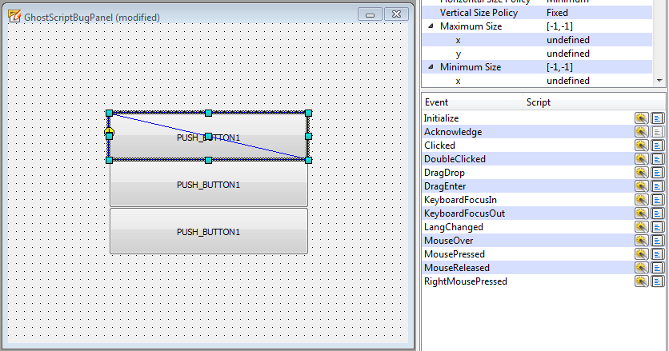
1 - Select object and open the event triggered script editor

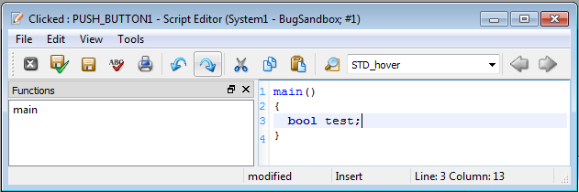
2 - Create and save any non-blank script

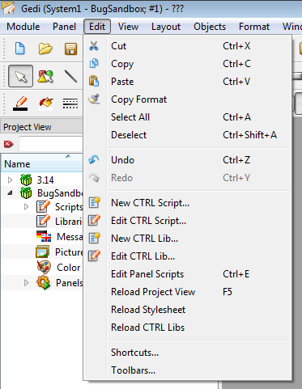
3 - Open the panel script editor

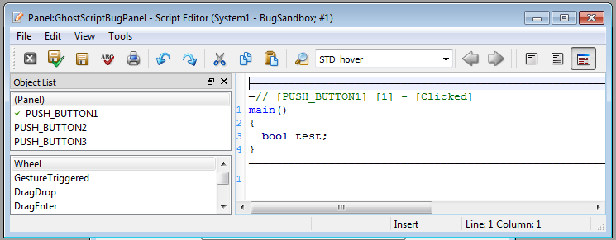
4 - Select and delete the whole script from the panel editor and save

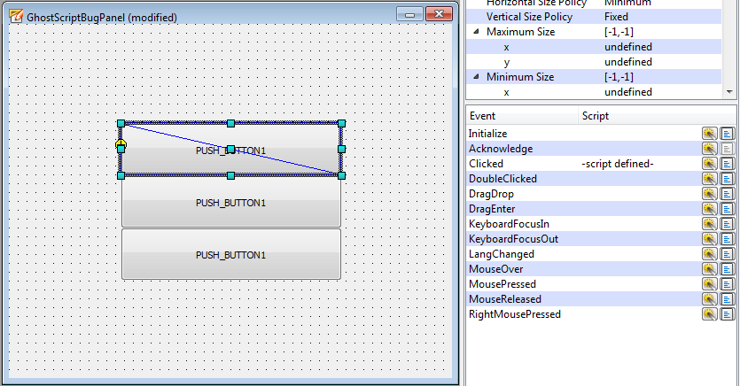
5 - In the gedi, select the object for which you made the script. Noticed the "script defined" label is still showing. Next open the complex screen editor

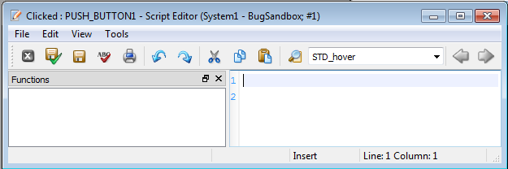
6 - The script shows two blank lines which when deleted and saved just return when you re-open the editor. The "script defined" label still remains

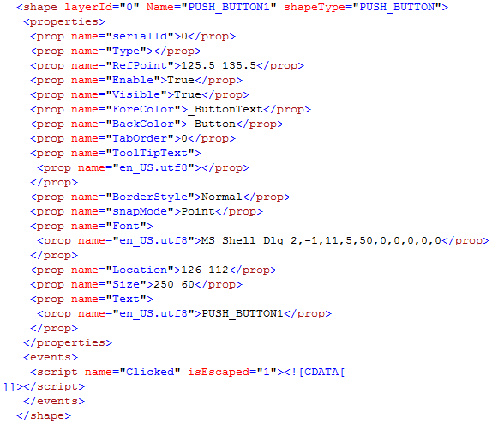
7- xml script of object with "ghost" script

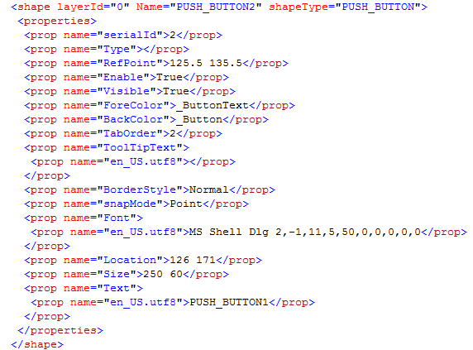
8 - xml script for identical object without "ghost" script

