Bug report: rotation mode not working in 3.15 - April 19th 2017
Walter Diurno, PRI – West Babylon, NY – 631 643 3170 ext.203 – walter.diurno@priinc.com

Test 3.14

Create a simple object

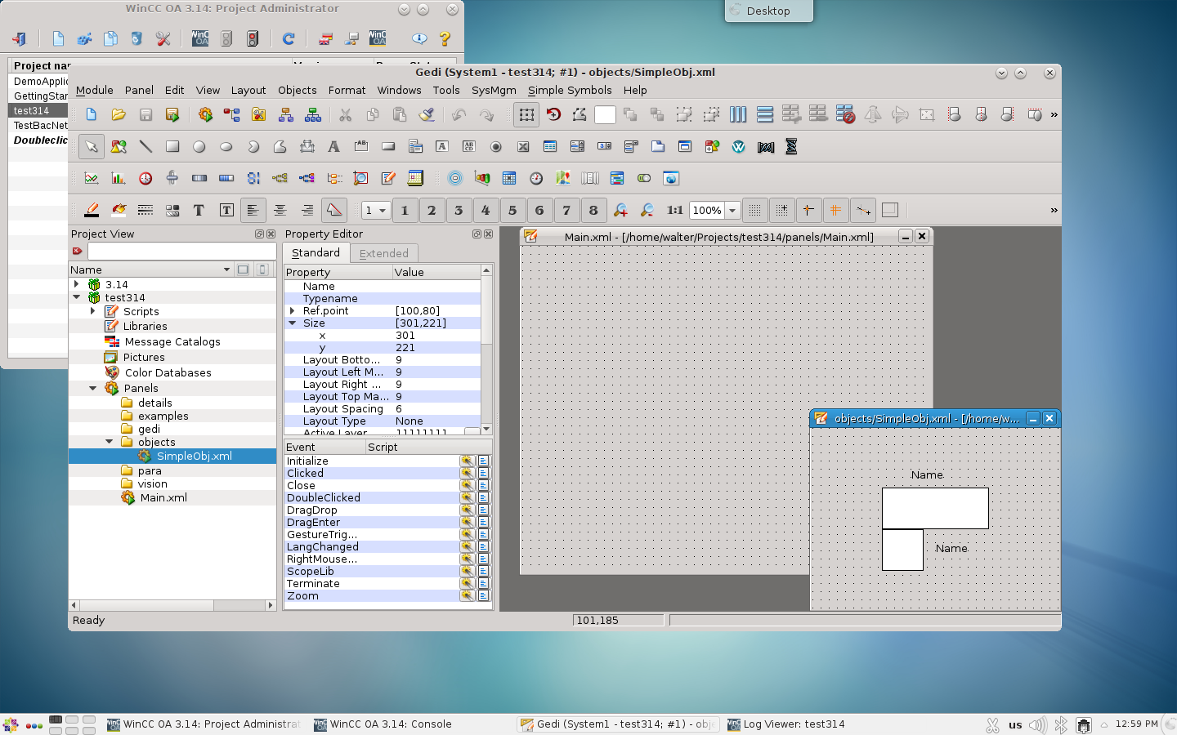

drag&drop on the Main panel:

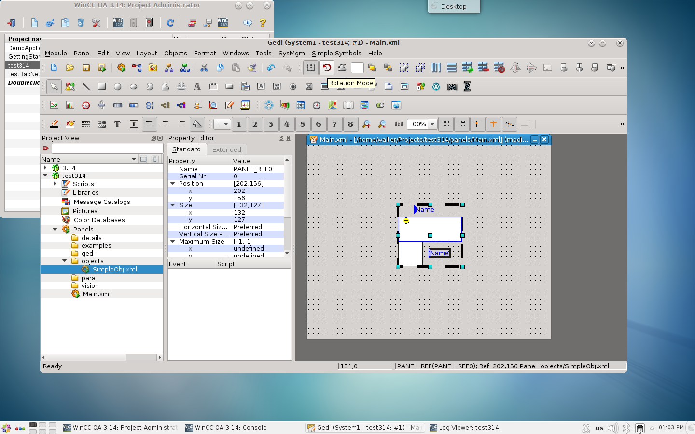

The rotation mode is active and the object can be rotated and moved in the Main panel without any problems. Texts are also correctly rotated.

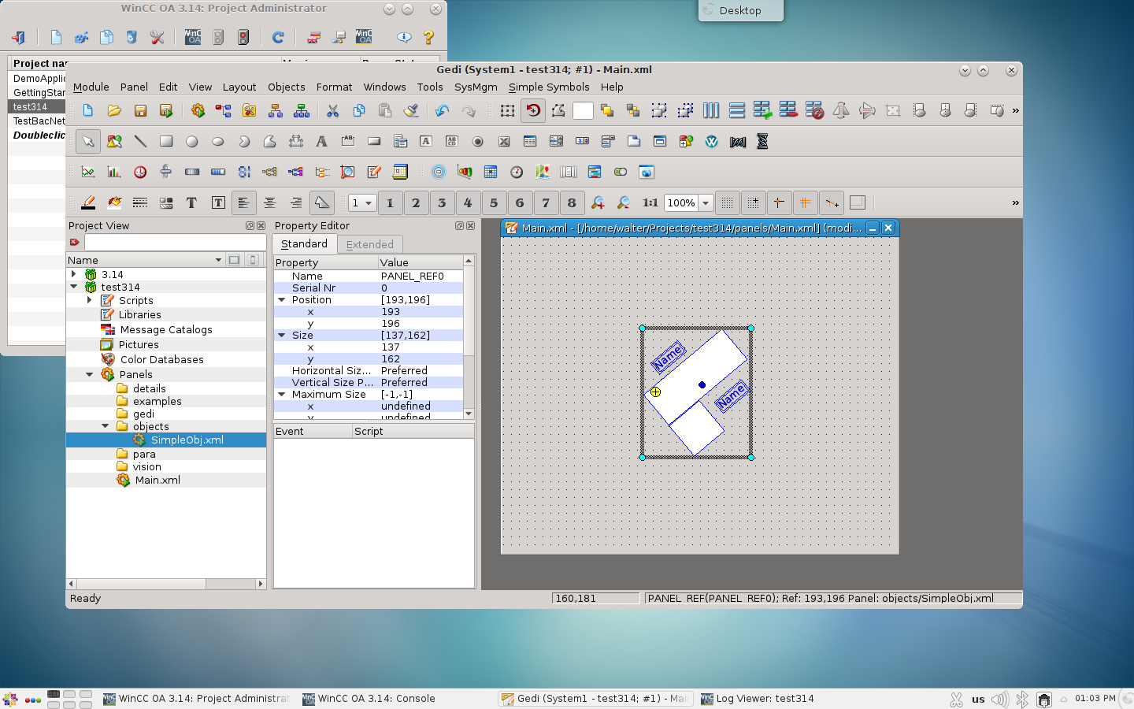
Test 3.15
Same object and Main panel:

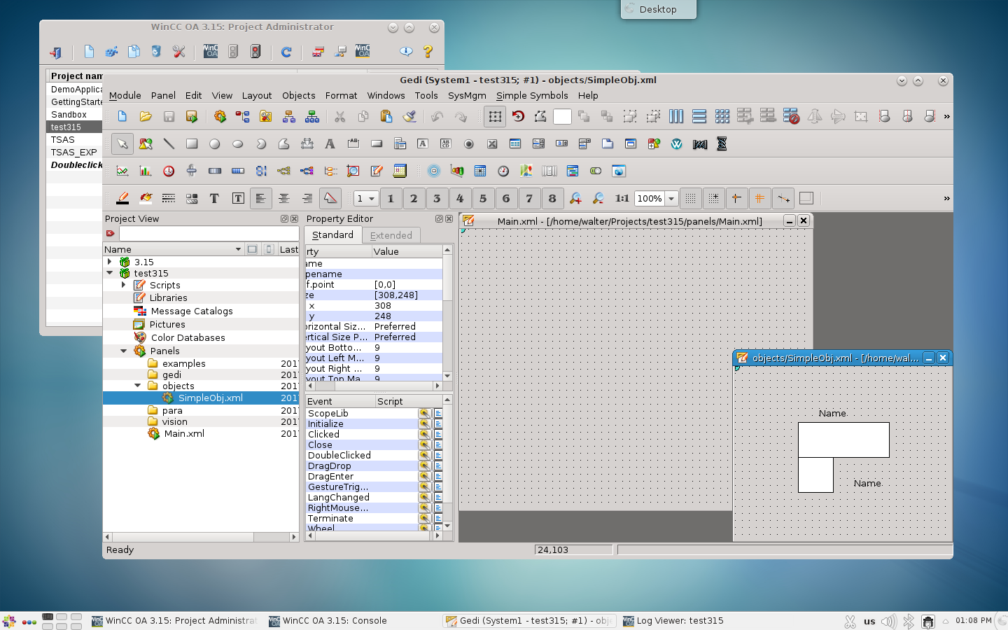

Drag&drop on main panel:

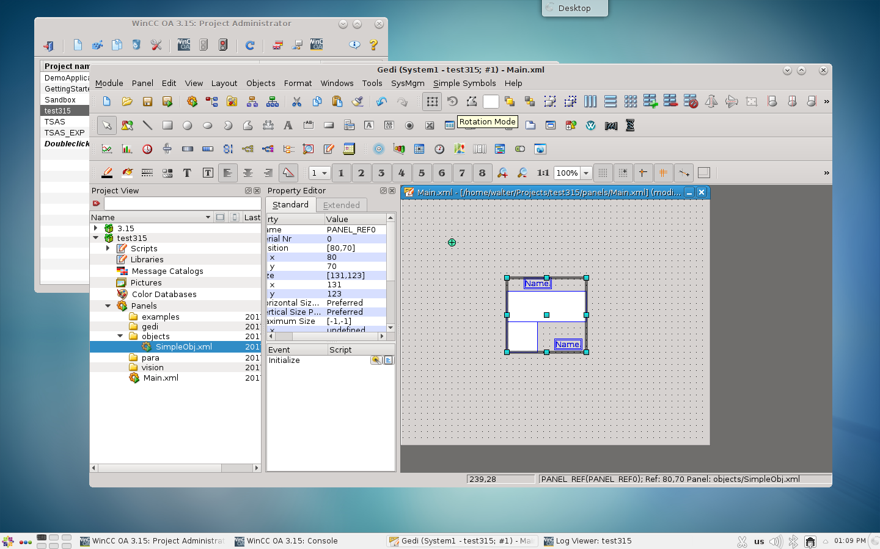

As you can see the rotation mode is greyed and cannot be used

I have added another simple object with an extended property to create a rotation method:

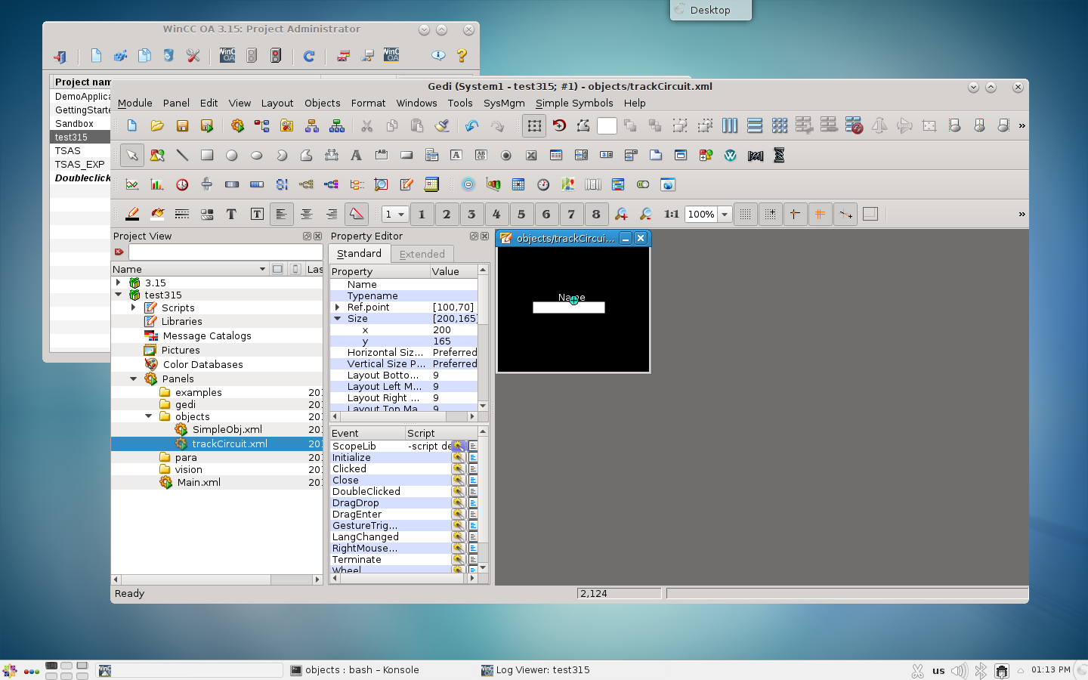

Script in ScopeLib:

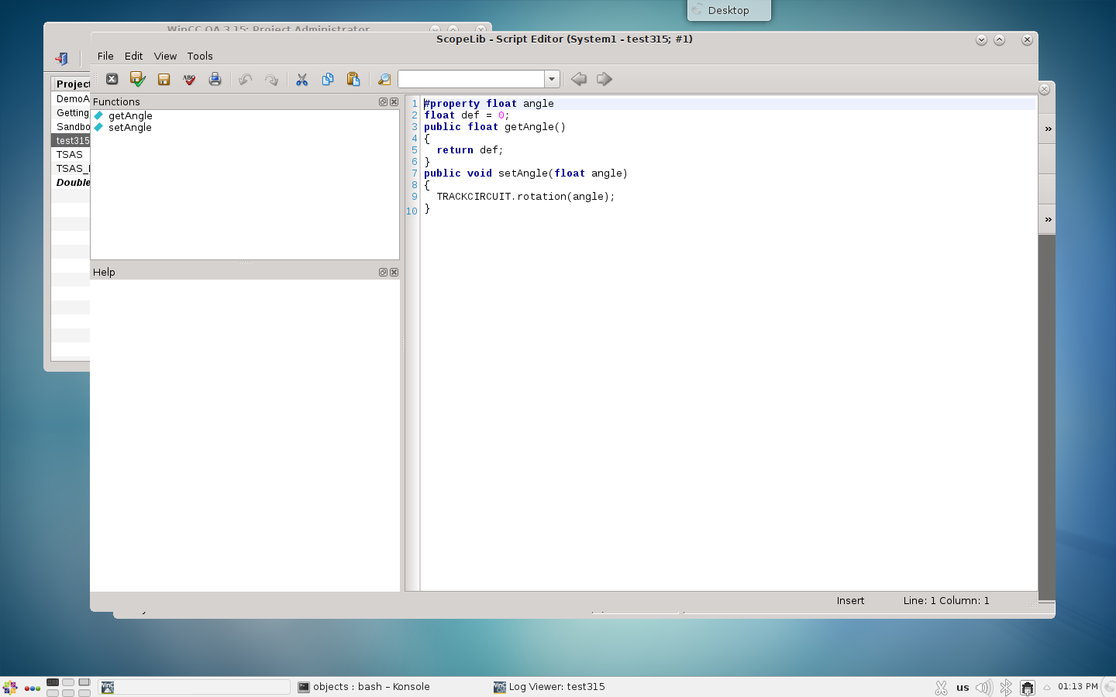

Drag&drop:

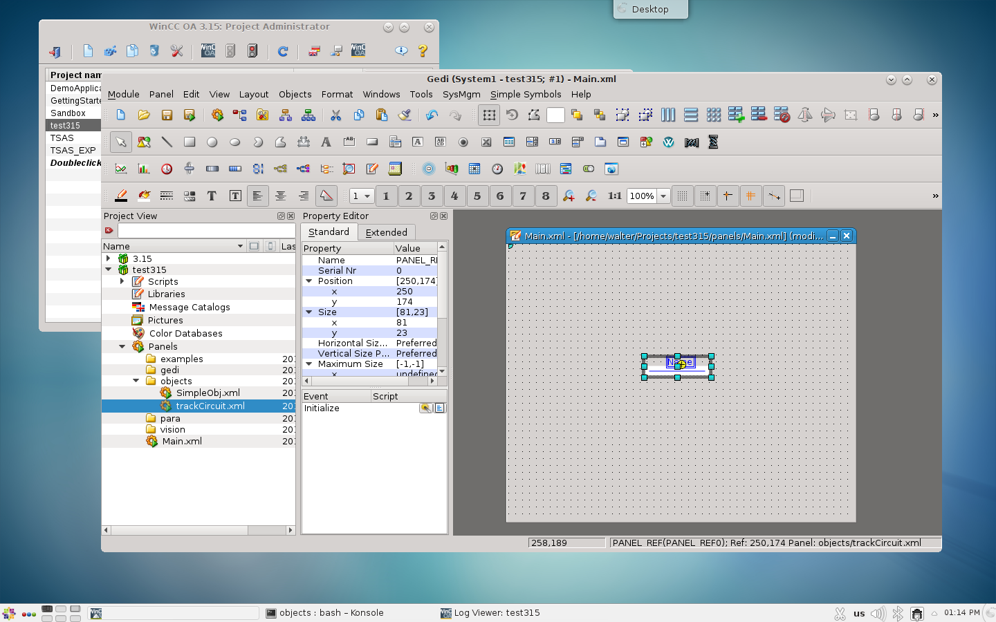

As you can see no rotation mode is available

Set a new angle using the property:

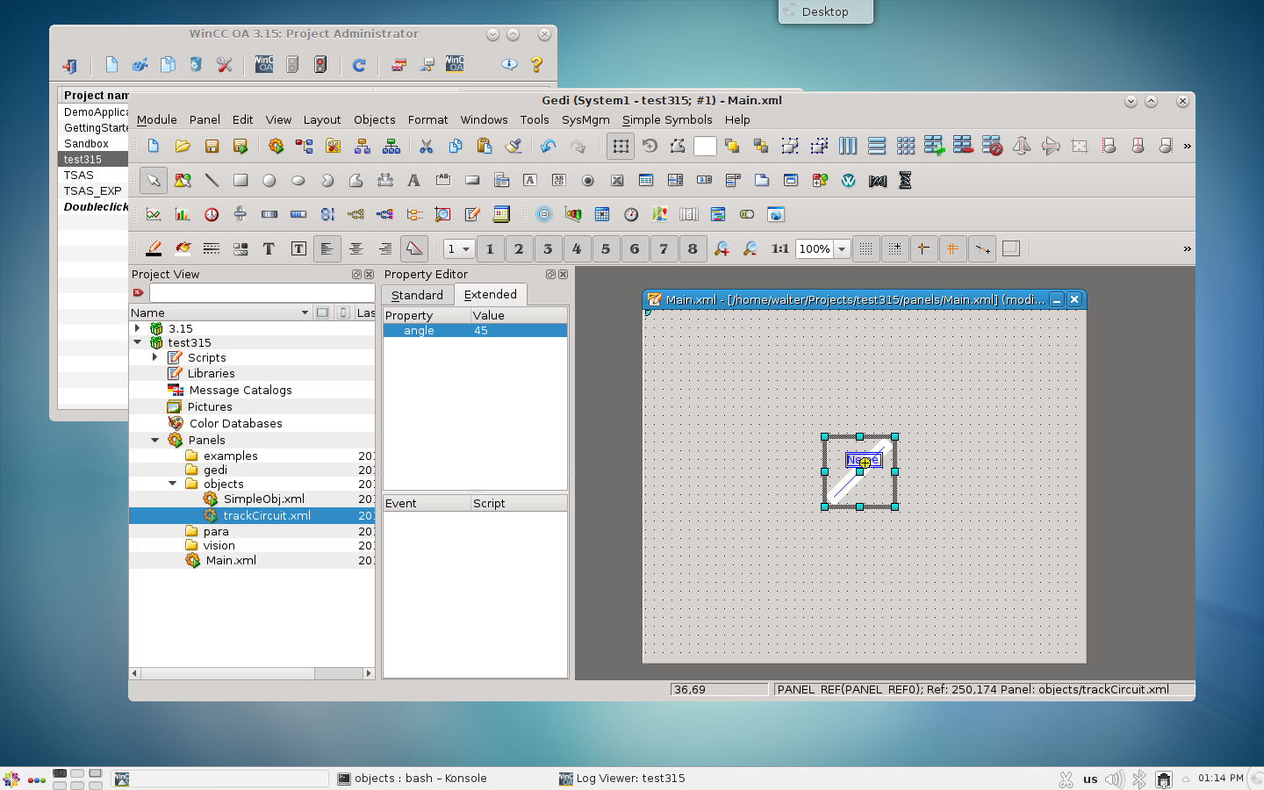

Clearly I could only rotate the rectangle, the label has not rotation property, thus this “fix” is already not equivalent to the 3.14 Rotation mode. But this is just the least of the problems.
When the object is moved after the rotation, it is deformed :

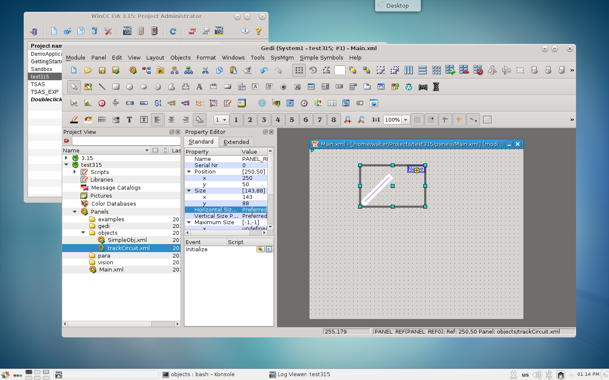

The movements are also completely messy. You move to the right the object move to the left or up(down). Also the position on the design screen and the run time screen do not match:

